A FIELD PROJECT REPORT

on

# “QUIZ MASTER”

**Submitted**

by

231FA04D32 231FA04D91

JAYASREE TEJA

231FA04E02 231FA04E19

BHANU SASANK ANAND KISHAN

**Under the guidance of**

*Mr. K. PAVAN KUMAR*

Assistant Professor, Department of CSE

**DEPARTMENT OF COMPUTER SCIENCE & ENGINEERING**

**VIGNAN'S FOUNDATION FOR SCIENCE, TECHNOLOGY AND RESEARCH Deemed to be UNIVERSITY Vadlamudi, Guntur.**

**ANDHRA PRADESH, INDIA, PIN-522213 May-2024.**



This is to certify that the Field Project entitled **“QUIZ MASTER”** that is being submitted by 231FA04D32(Jayasree), 231FA04D91(Teja), 231FA04E02(Bhanu) and 231FA04F67(Anand) for partial fulfilment of Field Project is a bonafide work carried out under the supervision of Mr. K Pavan Kumar, Assistant Professor, Department of

CSE.

Dr. S.V Phani Kumar

HOD, CSE

Mr. K. PAVAN KUMAR

Assistant Professor, Department of CSE



## DECLARATION

We hereby declare that the Field Project entitled **“QUIZ MASTER”** that is being submitted by 231FA04D32(Jayasree), 231FA04D91(Teja),

231FA04E02(Bhanu) and 231FA04E19(Anand) in partial fulfilment of Field Project course work. This is our original work, and this project has not formed the basis for the award of any degree. We have worked under the supervision of Mr.

K Pavan Kumar, Assistant Professor, Department of CSE.

**By**

**231FA04D32(JAYASREE),**

**231FA04D91(TEJA),**

**231FA04E02(BHANU SASANK)**

**231FA04E19(ANAND KISHAN)**

Date:22-03-2025

## “QUIZ MASTER”

1. **Introduction:**

Welcome to *Quiz Master*, your go-to online quiz platform designed to make learning enjoyable and interactive. If you're passionate about science or entertainment, our website offers an exciting way to test your knowledge and discover new facts. Whether you're a student, a trivia enthusiast, or someone who just loves a challenge, *Quiz Master* is here to bring the fun back to learning.

We focus on two main quiz categories: General Science and Entertainment. Our quizzes cover a wide range of topics within these categories, providing an opportunity for you to explore different areas of knowledge and test what you know. With *Quiz Master*, you can engage in a fun and competitive environment that encourages learning through play.

**Key Features of "Quiz Master":**

1. **General Science Quizzes** – Explore topics such as biology, chemistry, physics, and earth science. These quizzes will challenge your understanding of the natural world and help you discover fascinating facts about the sciences.
2. **Entertainment Quizzes** – Test your knowledge of movies, TV shows, music, and pop culture. Whether you’re into the latest blockbusters or classic hits, our entertainment quizzes will keep you entertained and informed.
3. **Instant Feedback** – After every quiz, you’ll receive immediate feedback on your answers. This allows you to learn from your mistakes and discover new things along the way.
4. **Real-time Score Tracking** – Track your scores and challenge yourself to improve. You can also share your results with friends and family to spark friendly competition.

At *Quiz Master*, we believe that learning doesn’t have to be boring. With our fun and engaging quizzes, you'll expand your knowledge, learn new things, and enjoy the process.

1. **Technologies Used**

Frontend: HTML, CSS, JavaScript

The *Quiz Master* platform is built using three core web technologies: **HTML**, **CSS**, and **JavaScript**. These technologies work together to create an interactive, visually appealing, and functional quiz website.

1. **HTML(HypertextMarkupLanguage):**  
   HTML forms the backbone of the *Quiz Master* website, providing the basic structure and content. It defines elements such as the quiz questions, buttons, headers, and text. By using elements like <div>, <section>, <header>, and <footer>, HTML ensures that all content is organized logically and is accessible to users. It also ensures compatibility across different devices and browsers.
2. **CSS(CascadingStyleSheets):**  
   CSS is responsible for styling the content and layout of the *Quiz Master* website. Through CSS, the platform’s appearance is customized with elements like colours, fonts, and spacing. Responsive design techniques such as Flexbox and Grid are used to ensure the platform adapts to various screen sizes, providing a smooth experience whether accessed on a desktop or mobile device. CSS also allows for the use of animations and transitions, making quiz interactions visually engaging.
3. **JavaScript:**  
   JavaScript adds interactivity and dynamic functionality to the *Quiz Master* platform. It is used to handle user input, process quiz responses, and provide instant feedback. JavaScript enables features like quiz navigation, score tracking, and the display of correct answers in real-time. It also ensures that the quiz responds instantly to user actions, without requiring page reloads, enhancing the overall experience.

These three technologies — HTML, CSS, and JavaScript — come together to create a seamless, interactive, and enjoyable experience for users of the *Quiz Master* platform. By leveraging the power of these technologies, the website offers a user-friendly interface that allows users to test and expand their knowledge in a fun, engaging way.

1. **Project Description:**

The Quiz Master platform is an engaging, web-based quiz website designed to offer users a fun and interactive way to test and improve their knowledge in two primary areas: General Science and Entertainment. This project was created with the goal of providing an educational tool that makes learning enjoyable and accessible to users of all ages, by offering quizzes that challenge and expand their understanding of specific topics.

The platform is built using essential web technologies such as HTML, CSS, and JavaScript, ensuring a smooth, user-friendly experience. The quizzes cover a wide range of topics within the fields of science and entertainment, providing an exciting opportunity for users to explore new facts and test their existing knowledge. The Quiz Master platform also includes features that allow users to track their progress, making it easy to monitor improvements and revisit quizzes to refine their knowledge.

Project Objectives:

The primary objective of the Quiz Master project is to provide an interactive and enjoyable way to learn while offering users a chance to engage with educational content in an entertaining format. By offering quizzes on a variety of topics, the platform caters to a wide audience, helping them test their knowledge, learn from feedback, and track their progress over time.

Through its simple yet effective design, the Quiz Master platform aims to foster a love for learning, allowing users to explore diverse subjects in a fun, engaging, and non-intimidating way. The platform encourages self-improvement and critical thinking by offering a competitive element that motivates users to continuously challenge themselves and enhance their skills.

**Content:**

The Quiz Master platform is designed to provide an engaging and interactive learning experience for users interested in testing their knowledge in two key categories: General Science and Entertainment. The platform is structured to allow users to easily navigate through a variety of quizzes, ranging from biology, chemistry, and physics to movies, TV shows, music, and pop culture. This variety ensures that the platform caters to a broad audience with different interests, making it a fun and educational tool for all ages.

The platform's main features include the ability for users to start quizzes based on their preferred category, with each quiz presenting multiple-choice questions. After completing a quiz, users receive instant feedback on their answers, including explanations for incorrect responses, which helps reinforce learning. Additionally, users can track their scores and compare their performance against others through a leaderboard, motivating them to continue improving.

To further enhance the experience, Quiz Master is designed with a simple and intuitive interface that allows users to easily access quizzes, view their progress, and explore new topics. The platform's responsive design ensures that users can participate in quizzes from any device, whether it's a desktop, tablet, or smartphone, offering flexibility for users to engage with the platform wherever they are.

In addition to quiz-taking, Quiz Master provides a space for users to explore educational content while competing in a friendly and motivating environment. The platform’s mission is to make learning enjoyable by combining fun, challenge, and education in a way that encourages users to expand their knowledge in a stress-free, interactive manner. By offering quizzes that span across various subjects, Quiz Master aims to foster curiosity, intellectual growth, and a sense of achievement in every user.

**Output:**

Login Page:

Home Page:

Sign In Page:



About us Page:

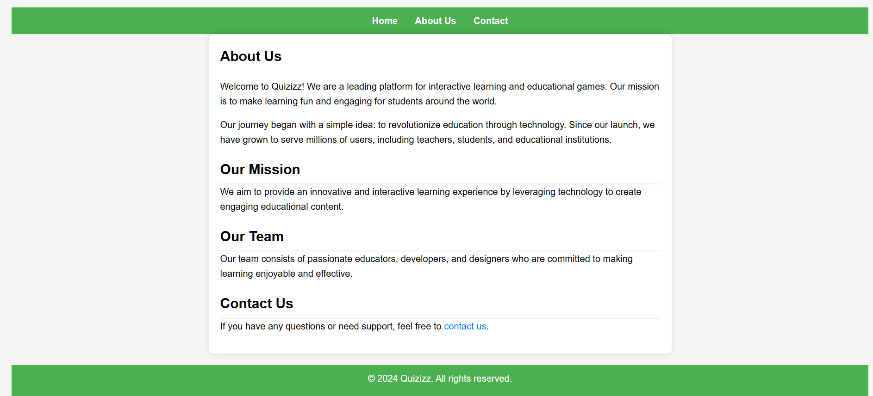

General knowledge Quiz Page:

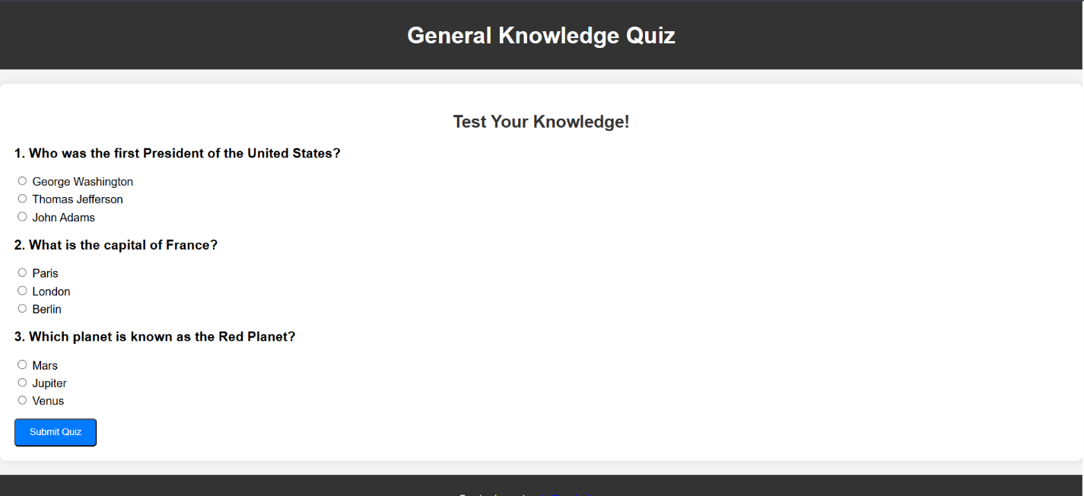

Science And Nature Quiz Page:

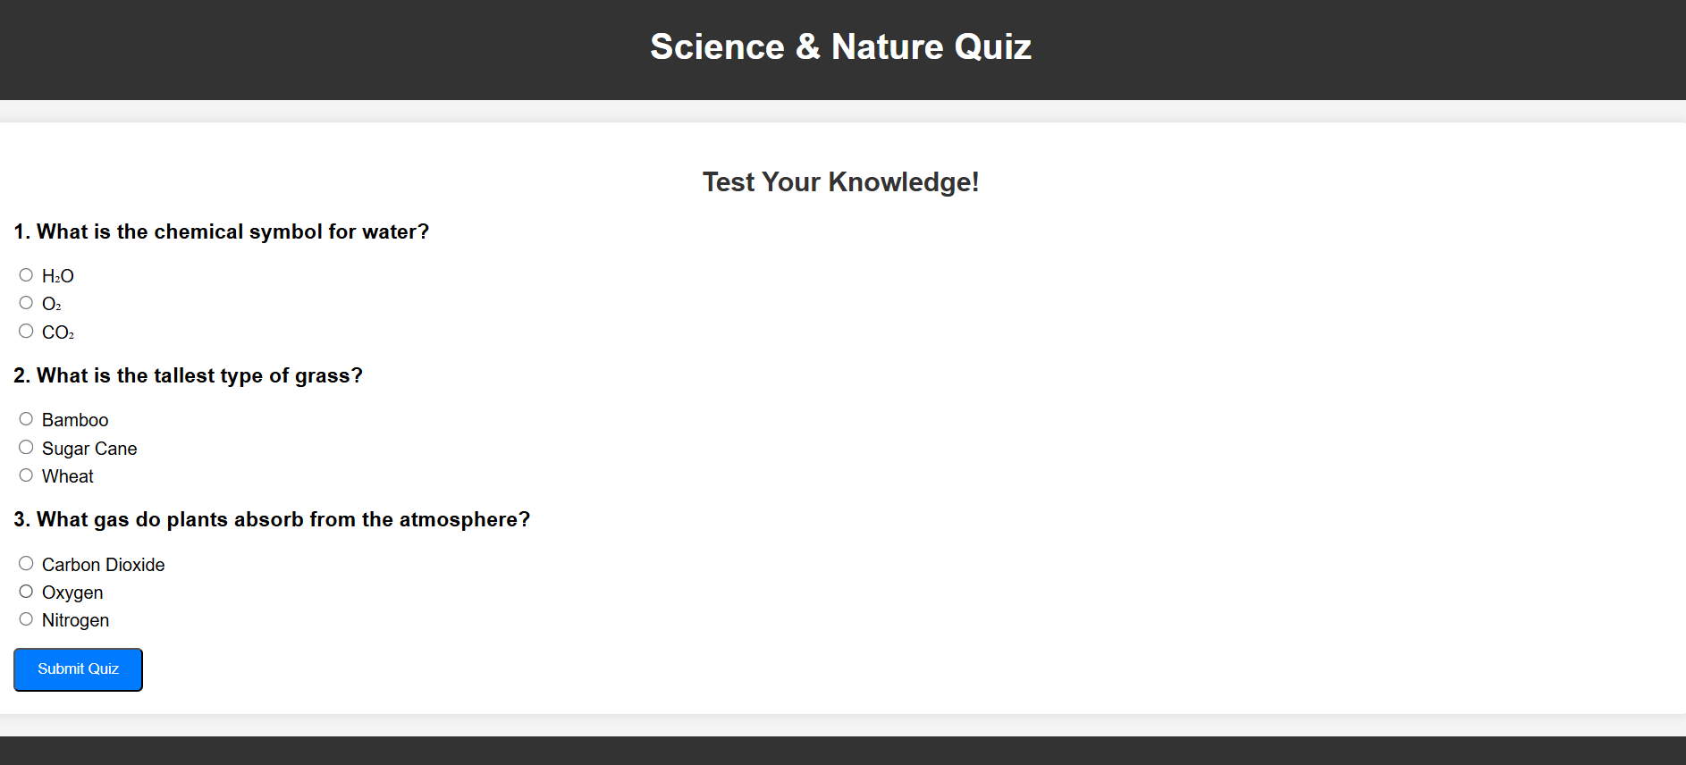

Entertainment Quiz Page:

**4. Conclusion:**

The *Quiz Master* platform successfully combines education and entertainment, offering users an engaging and interactive way to test their knowledge in various subjects like General Science and Entertainment. With its user-friendly interface, instant feedback, and real-time score tracking, the platform ensures that learning is both fun and effective. By providing quizzes that cater to a wide range of interests, it fosters a competitive yet educational environment, motivating users to continually challenge themselves and improve. Whether for personal development or simply for fun, *Quiz Master* makes learning an enjoyable and rewarding experience, encouraging users to explore new topics and expand their knowledge in a dynamic way.

**Project Link:**